Project 1 – Netflix and Chill?!?

Date: 07/25/2022

Georgia Tech Bootcamp 2022

Group 1:

Basimamovic, Vedrana

Brown, Kelly

Davis, Daulton

Hall, Brian

Mohamed, Hassan

Moody, Orlvertta

Johnson, Joseph

Lee, Leon

Zhu, Valentina

Objective:

Netflix is one of top streaming services which offers a wide variety of award-winning tv shows, movies, original content and much more. Our group analysis will explore Netflix dataset through visualizations and graphs using python libraries and five answers to trends among four genres: Action, Horror, Documentary, and Comedy.

Further, we will review the following:

* Quantity of each genre (how many)
* Quality of each genre (IMDb average rating)
* Which movie was the most popular for Netflix for the specific genre (TMDB)
* Which actor/actress was most featured for the specific genre

Data Set Source:

<https://www.kaggle.com/datasets/shivamb/netflix-shows>

<https://www.kaggle.com/datasets/victorsoeiro/netflix-tv-shows-and-movies>

<https://developers.themoviedb.org/>

**Project Title:**

**Members:** Vedrana Basimamovic, Kelly Brown, Hassan Mohamed, Brian Hall, Joseph Johnson, Daulton Davis, Leon Lee, Orlvertta Moody, Valentina Zhu

**Project Description/Outline:** Analyzing stock trends of streaming service providers ( past 6 months or for one quarter?)

1. Look at financial data, news articles

Netflix/~~Hulu/fuboTV/Sling/Roku/~~Disney+/Amazon Prime Video

~~Increase in streaming platforms and users~~

~~Age (correlation between age and users and which apps they are using)~~

~~Geographical~~

~~IMDB (popular shows to what streaming service they are on)~~

Financials (stock market)

Who gained/dropped the most and why?

Company announcements (surge/drop)

**Research Questions to Answers:** ~~What factors lead to their gains and losses?~~ Do exclusive movies/shows affect the price of the stock? Do company announcements cause the stock to gain/lose? Do major world events impact streaming platforms? When were top rated shows released for that service and is there a correlation to the stock value?

**Datasets to be Used: (Bonus: Use at least one API)**

Rotten Tomatoes

Nielsen Ratings

IMDb

<https://data.nasdaq.com/tools/python>

NY Times

**Rough Breakdown of Tasks:**

**Phase 1:** Stock Market Data

Netflix - Vedrana, Leon

Disney+ - Daulton,

Amazon Prime Video -

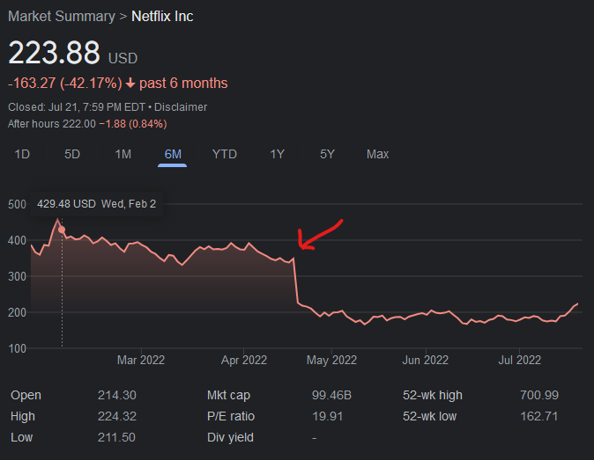

**Phase 2:** Movie/Show Data

7/21 - Start and Proposal

7/25 - Dataset to use - <https://gtvirtdatapt0-x3u8309.slack.com/files/U03JH8WNUMQ/F03QNERMSFP/netflix_tv_shows_and_movies.zip?origin_team=T03D1UR8YP9&origin_channel=C03Q3TPDNQP>

7/26 - subgroup part done

7/28-Put together

8/1-PowerPoint

8/2 - Presentations

|  | **Proficiency**  **20 points** |
| --- | --- |
| **Completed Analysis Uploaded to GitHub** | √ Final data analysis contains ample and complete information in README file  √ Final repository is acceptable for professional quality presentation |
| **Visualizations** | √ 6–8 visualizations of data (at least two per question)  √ Clear and accurate labeling of images  √ Visualizations supported with ample and precise explanation |
| **Analysis and Conclusion** | √ Write-up summarizes major findings and implications at a professional level  √ Each question in the project proposal is answered with precise descriptions and findings  √ Findings are strongly supported with numbers and visualizations  √ Each question response is supported with a well-discerned statistical analysis from lessons (e.g., aggregation, correlation, comparison, summary statistics, sentiment analysis, and time series analysis) |
| **Group Presentation** | √ All group members spoke during the presentation  √ Group was well prepared    √ Presentation is relevant to material  √ Presentation maintains audience interest |
| **Slide Deck** | √ Slides are visually clean and professional  √ Slides are relevant to material  √ Slides effectively demonstrate the project  √ Slides are clear and maintain audience interest |

**Agenda for 7/25**

Create repository

Get proposal approved

Git hub link: ?

Ideas/Questions

**General: Netflix trend in each genre 2021- present: List and ratings, views, most watched actors/actresses**

Anna: Main Dataset and Coordination **(How often does Netflix upload new content)**

Kelly & Joseph: Horror

Leon & Brian: Action

Valentina & Daulton: Documentary

Hassan & Vertta: Comedy

Questions to Answer:

- Quantity of each genre (how many)

- Quality of each genre (IMDb average rating)

- Which movie was the most popular for Netflix for the specific genre (TMDB?)

- Which actor/actress was most featured for the specific genre

* ~~How often do streaming services upload new content? (genre specific)~~
* ~~Average time movies/dramas are up on these streaming services~~
* ~~Most popular genres for each streaming service~~
* ~~Dramas or Movies? What streaming service has more~~
* ~~Which composition of service makes the most profit? (total gross)~~
* ~~Top streaming service for comedy, docu-series, animation (or for different genres)~~
* Pick one movie genre - highest frequency/output/quantity/user rating (quality)
* Most shown actor/director for each streaming service
* Highest customer rated movies (foreign), quantity of horror movies & documentaries
* Quantity and quality of each genre (****)
* Movies directed by women/minorities
* Pick Netflix and pick 3-4 specifics (****)

- Quantity of each genre

- Quality of each genre

- Which actor/director was the most popular for Netflix

Numerous Services

Specific Service